1 run

training 1 epoch...

28.867160081863403 seconds used......

1 training finished! average train loss: 1.0328306701448229

evaluating...

Confusion matrix, without normalization

[[ 48 29 13]

[ 9 49 9]

[ 45 95 204]]

Normalized confusion matrix

[[0.53333333 0.32222222 0.14444444]

[0.13432836 0.73134328 0.13432836]

[0.13081395 0.27616279 0.59302326]]

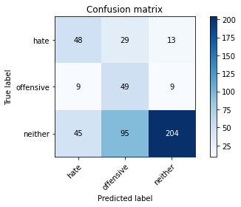

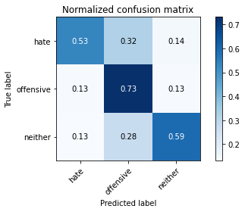

precision recall f1-score support

hate 0.47 0.53 0.50 90

offensive 0.28 0.73 0.41 67

neither 0.90 0.59 0.72 344

accuracy 0.60 501

macro avg 0.55 0.62 0.54 501

weighted avg 0.74 0.60 0.64 501

average eval_loss: 0.8839616087766794, accuracy: 0.6007984031936128

training 2 epoch...

31.668907403945923 seconds used......

2 training finished! average train loss: 0.7639269825485018

evaluating...

Confusion matrix, without normalization

[[ 54 25 11]

[ 12 47 8]

[ 59 63 222]]

Normalized confusion matrix

[[0.6 0.27777778 0.12222222]

[0.17910448 0.70149254 0.11940299]

[0.17151163 0.18313953 0.64534884]]

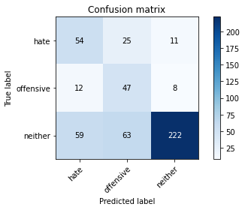

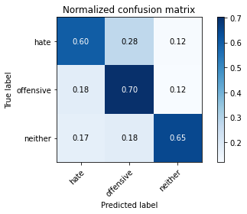

precision recall f1-score support

hate 0.43 0.60 0.50 90

offensive 0.35 0.70 0.47 67

neither 0.92 0.65 0.76 344

accuracy 0.64 501

macro avg 0.57 0.65 0.58 501

weighted avg 0.76 0.64 0.67 501

average eval_loss: 0.754387186983457, accuracy: 0.6447105788423154

training 3 epoch...

32.22542476654053 seconds used......

3 training finished! average train loss: 0.5042501924766435

evaluating...

Confusion matrix, without normalization

[[ 49 23 18]

[ 10 46 11]

[ 34 34 276]]

Normalized confusion matrix

[[0.54444444 0.25555556 0.2 ]

[0.14925373 0.68656716 0.1641791 ]

[0.09883721 0.09883721 0.80232558]]

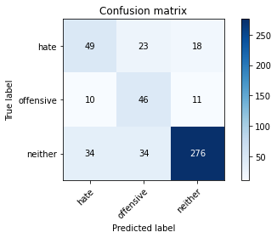

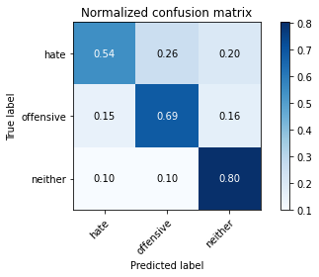

precision recall f1-score support

hate 0.53 0.54 0.54 90

offensive 0.45 0.69 0.54 67

neither 0.90 0.80 0.85 344

accuracy 0.74 501

macro avg 0.63 0.68 0.64 501

weighted avg 0.78 0.74 0.75 501

average eval_loss: 0.6014292720132149, accuracy: 0.7405189620758483

training 4 epoch...

31.066060543060303 seconds used......

4 training finished! average train loss: 0.2780001748767164

evaluating...

Confusion matrix, without normalization

[[ 52 24 14]

[ 11 49 7]

[ 49 39 256]]

Normalized confusion matrix

[[0.57777778 0.26666667 0.15555556]

[0.1641791 0.73134328 0.10447761]

[0.14244186 0.11337209 0.74418605]]

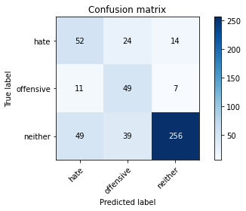

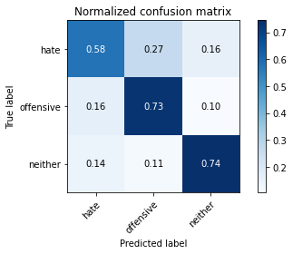

precision recall f1-score support

hate 0.46 0.58 0.51 90

offensive 0.44 0.73 0.55 67

neither 0.92 0.74 0.82 344

accuracy 0.71 501

macro avg 0.61 0.68 0.63 501

weighted avg 0.78 0.71 0.73 501

average eval_loss: 0.7287973506519427, accuracy: 0.7125748502994012

training 5 epoch...

31.946470260620117 seconds used......

5 training finished! average train loss: 0.1107944430783391

evaluating...

Confusion matrix, without normalization

[[ 49 26 15]

[ 10 53 4]

[ 41 60 243]]

Normalized confusion matrix

[[0.54444444 0.28888889 0.16666667]

[0.14925373 0.79104478 0.05970149]

[0.11918605 0.1744186 0.70639535]]

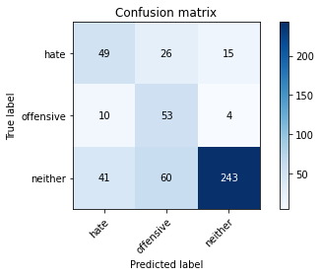

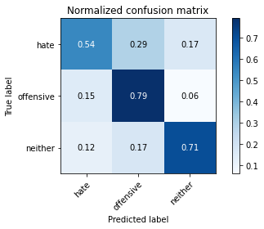

precision recall f1-score support

hate 0.49 0.54 0.52 90

offensive 0.38 0.79 0.51 67

neither 0.93 0.71 0.80 344

accuracy 0.69 501

macro avg 0.60 0.68 0.61 501

weighted avg 0.78 0.69 0.71 501

average eval_loss: 1.1921115563465998, accuracy: 0.688622754491018

model of 2 epoch

Confusion matrix, without normalization

[[ 340 225 208]

[ 60 251 119]

[ 292 385 1652]]

Normalized confusion matrix

[[0.43984476 0.29107374 0.2690815 ]

[0.13953488 0.58372093 0.27674419]

[0.1253757 0.165307 0.7093173 ]]

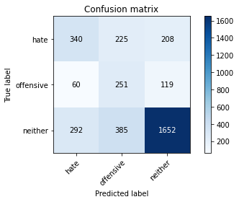

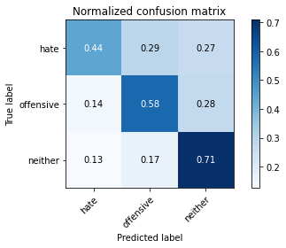

precision recall f1-score support

hate 0.49 0.44 0.46 773

offensive 0.29 0.58 0.39 430

neither 0.83 0.71 0.77 2329

accuracy 0.64 3532

macro avg 0.54 0.58 0.54 3532

weighted avg 0.69 0.64 0.65 3532

average eval_loss: 0.8193540014116104, accuracy: 0.6350509626274066

2 run

training 1 epoch...

16.49792742729187 seconds used......

1 training finished! average train loss: 1.0732541249858008

evaluating...

Confusion matrix, without normalization

[[ 64 12 14]

[ 23 20 24]

[ 85 38 221]]

Normalized confusion matrix

[[0.71111111 0.13333333 0.15555556]

[0.34328358 0.29850746 0.35820896]

[0.24709302 0.11046512 0.64244186]]

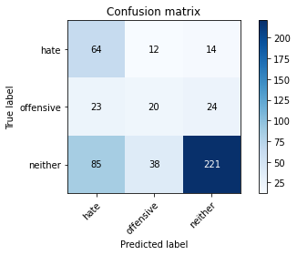

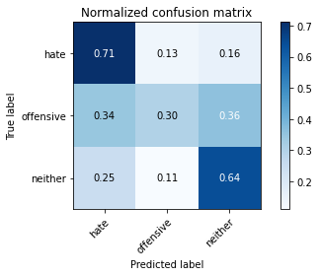

precision recall f1-score support

hate 0.37 0.71 0.49 90

offensive 0.29 0.30 0.29 67

neither 0.85 0.64 0.73 344

accuracy 0.61 501

macro avg 0.50 0.55 0.50 501

weighted avg 0.69 0.61 0.63 501

average eval_loss: 0.9291361845456637, accuracy: 0.6087824351297405

training 2 epoch...

15.594138622283936 seconds used......

2 training finished! average train loss: 0.8063624103864034

evaluating...

Confusion matrix, without normalization

[[ 58 17 15]

[ 22 35 10]

[ 67 44 233]]

Normalized confusion matrix

[[0.64444444 0.18888889 0.16666667]

[0.32835821 0.52238806 0.14925373]

[0.19476744 0.12790698 0.67732558]]

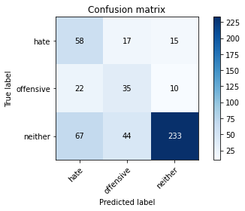

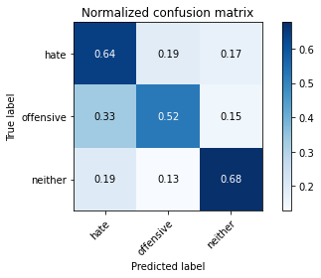

precision recall f1-score support

hate 0.39 0.64 0.49 90

offensive 0.36 0.52 0.43 67

neither 0.90 0.68 0.77 344

accuracy 0.65 501

macro avg 0.55 0.61 0.56 501

weighted avg 0.74 0.65 0.68 501

average eval_loss: 0.7860706276618518, accuracy: 0.6506986027944112

training 3 epoch...

15.587770700454712 seconds used......

3 training finished! average train loss: 0.5339779977997144

evaluating...

Confusion matrix, without normalization

[[ 59 22 9]

[ 20 42 5]

[ 77 68 199]]

Normalized confusion matrix

[[0.65555556 0.24444444 0.1 ]

[0.29850746 0.62686567 0.07462687]

[0.22383721 0.19767442 0.57848837]]

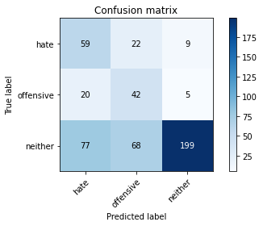

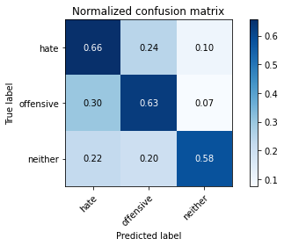

precision recall f1-score support

hate 0.38 0.66 0.48 90

offensive 0.32 0.63 0.42 67

neither 0.93 0.58 0.71 344

accuracy 0.60 501

macro avg 0.54 0.62 0.54 501

weighted avg 0.75 0.60 0.63 501

average eval_loss: 0.9700149561350162, accuracy: 0.5988023952095808

training 4 epoch...

15.600085735321045 seconds used......

4 training finished! average train loss: 0.30341603176461324

evaluating...

Confusion matrix, without normalization

[[ 63 15 12]

[ 21 39 7]

[ 77 32 235]]

Normalized confusion matrix

[[0.7 0.16666667 0.13333333]

[0.31343284 0.58208955 0.10447761]

[0.22383721 0.09302326 0.68313953]]

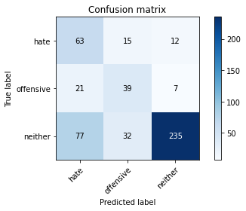

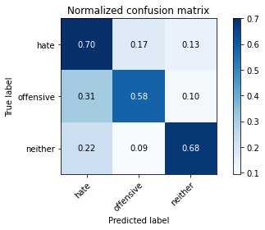

precision recall f1-score support

hate 0.39 0.70 0.50 90

offensive 0.45 0.58 0.51 67

neither 0.93 0.68 0.79 344

accuracy 0.67 501

macro avg 0.59 0.66 0.60 501

weighted avg 0.77 0.67 0.70 501

average eval_loss: 0.8309905093449813, accuracy: 0.6726546906187625

training 5 epoch...

15.595771074295044 seconds used......

5 training finished! average train loss: 0.13246320254272884

evaluating...

Confusion matrix, without normalization

[[ 54 21 15]

[ 14 44 9]

[ 49 31 264]]

Normalized confusion matrix

[[0.6 0.23333333 0.16666667]

[0.20895522 0.65671642 0.13432836]

[0.14244186 0.09011628 0.76744186]]

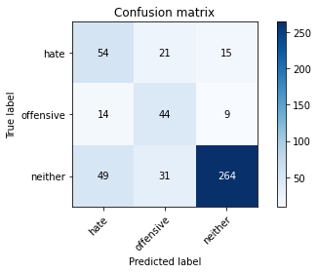

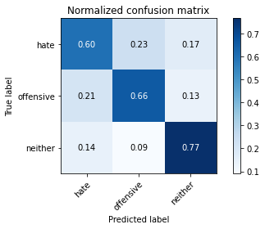

precision recall f1-score support

hate 0.46 0.60 0.52 90

offensive 0.46 0.66 0.54 67

neither 0.92 0.77 0.84 344

accuracy 0.72 501

macro avg 0.61 0.67 0.63 501

weighted avg 0.77 0.72 0.74 501

average eval_loss: 0.8305463527257626, accuracy: 0.7225548902195609

Confusion matrix, without normalization

[[ 411 87 275]

[ 146 117 167]

[ 520 175 1634]]

Normalized confusion matrix

[[0.5316947 0.11254851 0.35575679]

[0.33953488 0.27209302 0.38837209]

[0.22327179 0.07513954 0.70158866]]

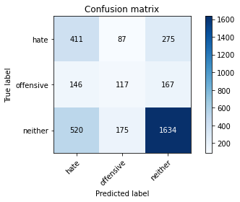

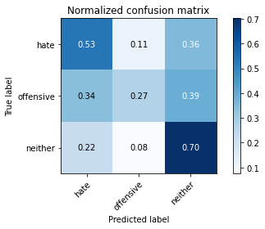

precision recall f1-score support

hate 0.38 0.53 0.44 773

offensive 0.31 0.27 0.29 430

neither 0.79 0.70 0.74 2329

accuracy 0.61 3532

macro avg 0.49 0.50 0.49 3532

weighted avg 0.64 0.61 0.62 3532

average eval_loss: 0.9401959672486041, accuracy: 0.6121177802944507

[18]:

0.6121177802944507

3 run

training 1 epoch...

15.646165370941162 seconds used......

1 training finished! average train loss: 1.0080661627981398

evaluating...

Confusion matrix, without normalization

[[ 55 13 22]

[ 21 24 22]

[ 38 42 264]]

Normalized confusion matrix

[[0.61111111 0.14444444 0.24444444]

[0.31343284 0.35820896 0.32835821]

[0.11046512 0.12209302 0.76744186]]

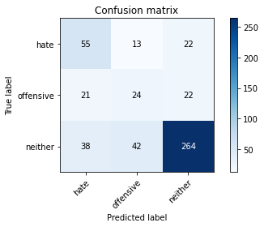

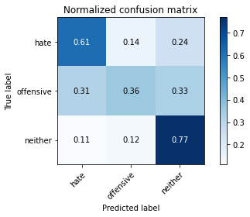

precision recall f1-score support

hate 0.48 0.61 0.54 90

offensive 0.30 0.36 0.33 67

neither 0.86 0.77 0.81 344

accuracy 0.68 501

macro avg 0.55 0.58 0.56 501

weighted avg 0.72 0.68 0.70 501

average eval_loss: 0.7768641297633831, accuracy: 0.6846307385229541

training 2 epoch...

15.5759117603302 seconds used......

2 training finished! average train loss: 0.7229066259331174

evaluating...

Confusion matrix, without normalization

[[ 65 10 15]

[ 26 32 9]

[ 50 44 250]]

Normalized confusion matrix

[[0.72222222 0.11111111 0.16666667]

[0.3880597 0.47761194 0.13432836]

[0.14534884 0.12790698 0.72674419]]

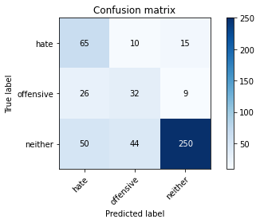

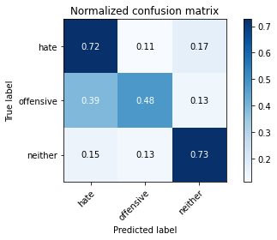

precision recall f1-score support

hate 0.46 0.72 0.56 90

offensive 0.37 0.48 0.42 67

neither 0.91 0.73 0.81 344

accuracy 0.69 501

macro avg 0.58 0.64 0.60 501

weighted avg 0.76 0.69 0.71 501

average eval_loss: 0.7074402054915061, accuracy: 0.6926147704590818

training 3 epoch...

15.61862301826477 seconds used......

3 training finished! average train loss: 0.4657960247662332

evaluating...

Confusion matrix, without normalization

[[ 57 23 10]

[ 15 47 5]

[ 56 75 213]]

Normalized confusion matrix

[[0.63333333 0.25555556 0.11111111]

[0.2238806 0.70149254 0.07462687]

[0.1627907 0.21802326 0.61918605]]

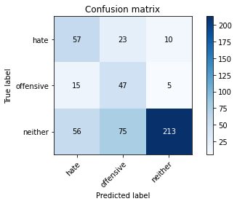

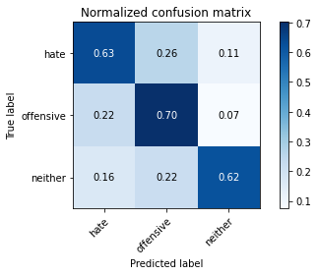

precision recall f1-score support

hate 0.45 0.63 0.52 90

offensive 0.32 0.70 0.44 67

neither 0.93 0.62 0.74 344

accuracy 0.63 501

macro avg 0.57 0.65 0.57 501

weighted avg 0.76 0.63 0.66 501

average eval_loss: 0.9047809415138685, accuracy: 0.6327345309381237

training 4 epoch...

15.554118394851685 seconds used......

4 training finished! average train loss: 0.2259915220240752

evaluating...

Confusion matrix, without normalization

[[ 46 31 13]

[ 10 51 6]

[ 40 57 247]]

Normalized confusion matrix

[[0.51111111 0.34444444 0.14444444]

[0.14925373 0.76119403 0.08955224]

[0.11627907 0.16569767 0.71802326]]

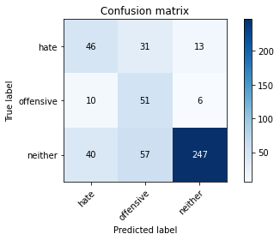

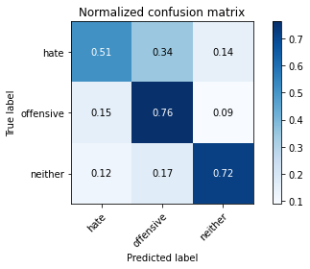

precision recall f1-score support

hate 0.48 0.51 0.49 90

offensive 0.37 0.76 0.50 67

neither 0.93 0.72 0.81 344

accuracy 0.69 501

macro avg 0.59 0.66 0.60 501

weighted avg 0.77 0.69 0.71 501

average eval_loss: 1.040853446492782, accuracy: 0.6866267465069861

training 5 epoch...

15.595217227935791 seconds used......

5 training finished! average train loss: 0.09919955891867478

evaluating...

Confusion matrix, without normalization

[[ 56 19 15]

[ 14 45 8]

[ 54 41 249]]

Normalized confusion matrix

[[0.62222222 0.21111111 0.16666667]

[0.20895522 0.67164179 0.11940299]

[0.15697674 0.11918605 0.72383721]]

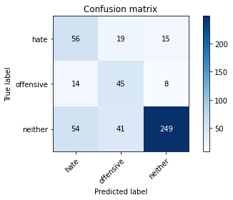

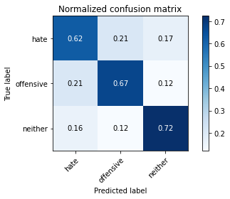

precision recall f1-score support

hate 0.45 0.62 0.52 90

offensive 0.43 0.67 0.52 67

neither 0.92 0.72 0.81 344

accuracy 0.70 501

macro avg 0.60 0.67 0.62 501

weighted avg 0.77 0.70 0.72 501

average eval_loss: 1.024958713495065, accuracy: 0.6986027944111777

Confusion matrix, without normalization

[[ 418 127 228]

[ 103 209 118]

[ 311 269 1749]]

Normalized confusion matrix

[[0.54075032 0.16429495 0.29495472]

[0.23953488 0.48604651 0.2744186 ]

[0.13353371 0.11550021 0.75096608]]

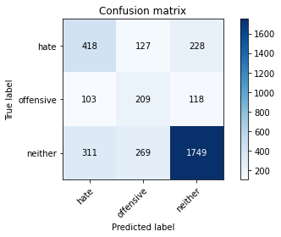

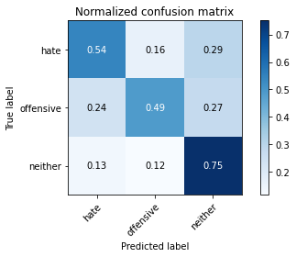

precision recall f1-score support

hate 0.50 0.54 0.52 773

offensive 0.35 0.49 0.40 430

neither 0.83 0.75 0.79 2329

accuracy 0.67 3532

macro avg 0.56 0.59 0.57 3532

weighted avg 0.70 0.67 0.68 3532

average eval_loss: 0.7794010570157046, accuracy: 0.6727066817667045

[20]:

0.6727066817667045